 

WORKSHEET-04

Student Name:-Ritika Rana UID:- 19BCA1126

Branch:- BCA Section/Group:- A/B

Semester:- 6th Date of Performance:- 09-03-2022 Subject Name:- Microprocessor And Interfacing Lab

Subject Code:- CAP-356

1. **Overview of the practical:**

# A memory location 3020H consist of data 45H and 3021H consist of 84H. Write a program to add to 8 bit numbers with carry and store the result at

3022H.

1. **Task to be done:**

LXI H, 3020H;

MOV A,M;

INX H;

MOV B,M; MVI C, 00H; ADD B;

JNC X; INR C;

X: INX H;

MOV M,A;

INX H;

MOV M,C;

HLT

1. **Tools Used:**

SIM 8055 (https:/[/www.sim8085.com/)](http://www.sim8085.com/))

1. **Output:**
2. **Learning outcomes (What I have learnt):**

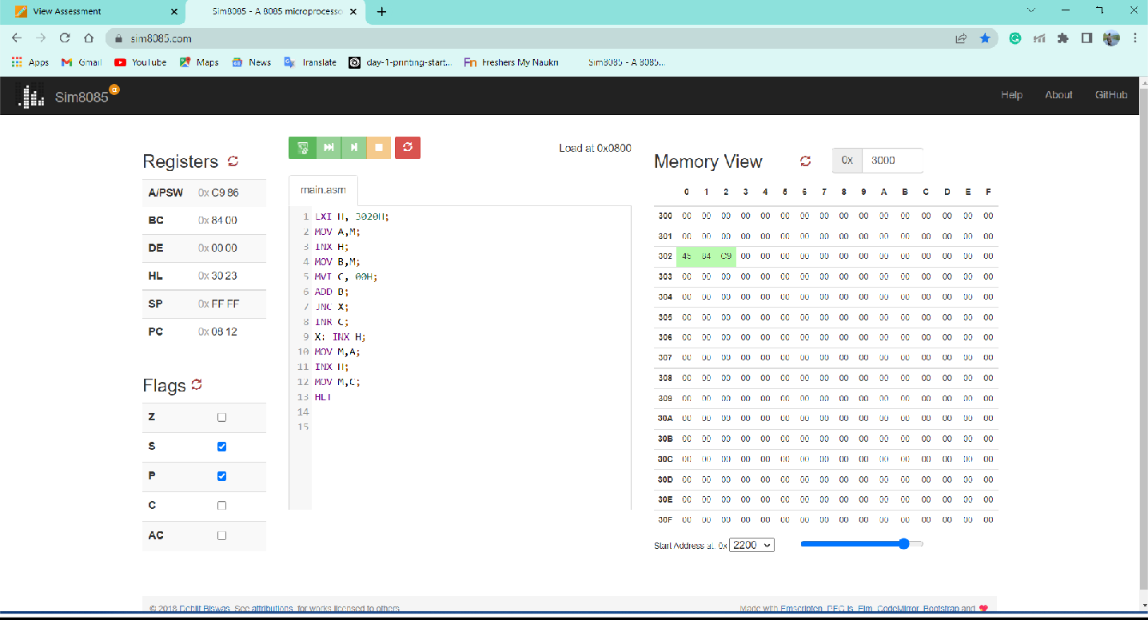

* 1. LXI H
  2. MVI
  3. INX
  4. MOV
  5. HLT (Used to end the program)
  6. **Evaluation Grid:**

|  |  |  |  |
| --- | --- | --- | --- |
| Sr. No. | Parameters | Marks Obtained | Maximum Marks |
| 1 | Demonstration/Performance/Pre Lab Quiz |  | 5 |
| 2 | Worksheet |  | 10 |
| 3 | Post Lab Quiz |  | 5 |